This file shows how to setup the model for the efficiency mapping manually.
Step 1 – First setup the output variables within the model of which you want to measure the performance.
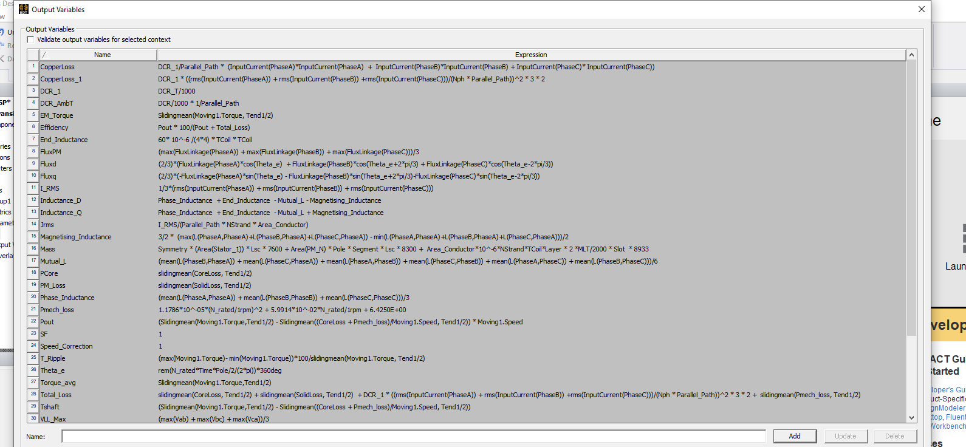
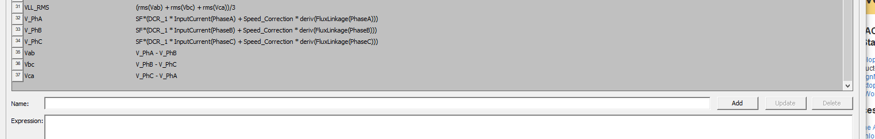
Step 2 – Then try to run the model once and get the graph as shown in the figure below. You can delete the data for that one simulation then. Keep in mind that you should consider the Torque_avg as important point. T_shaft will be very low or even negative at low speed (1 rpm), so you should not consider it. You can consider it as shown below but its not important within the results.
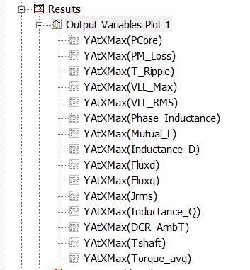
In order to get the graph or image above, the following steps are required.
Right click on the Results > Output variables > select all the variables as shown in the graph above > click on the range function then > New window opens > click on the arrow in the Function : select YAtXMax
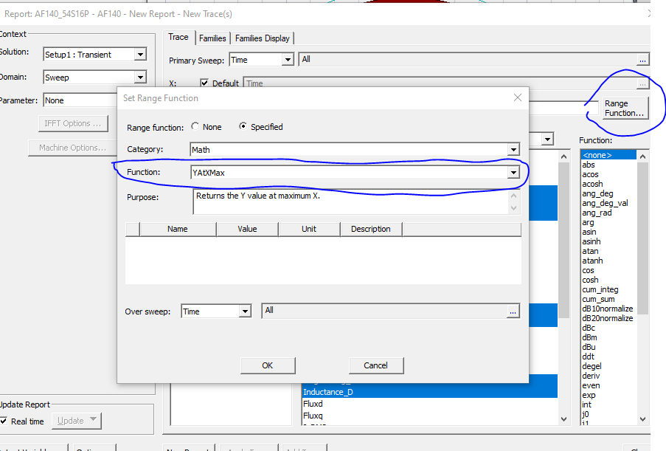
Then within the same window, click on Families , go down within the window and see Nominals > on the arrow select “Set all variables to Nominal”
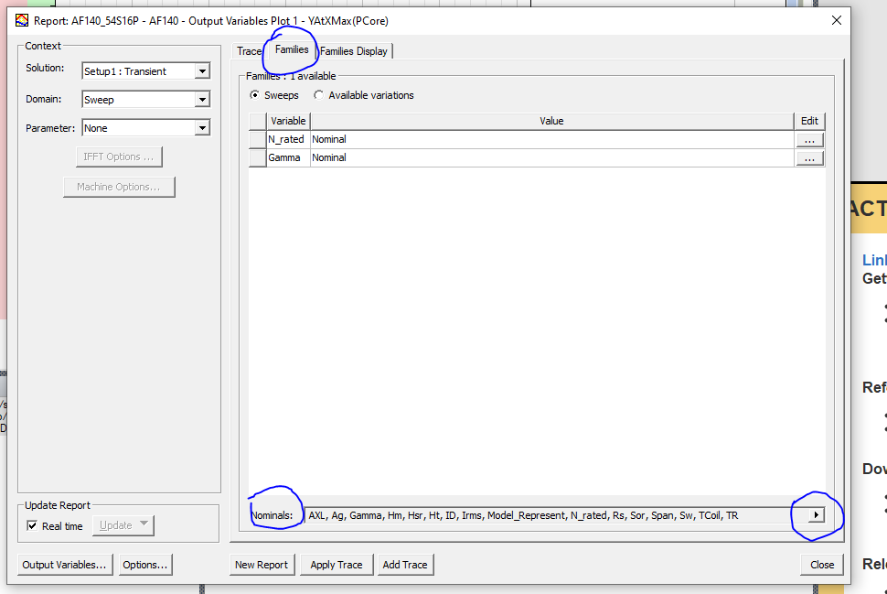

Step 3: Setp the optimeterics
In this case, you will try to setup the optimetrics – Since we are changing only 3 values, which are Current, Gamma and speed, the easy thing we can do is to make a csv file and transfer all the variations to the ParametricSetup1 i.e. right click on the optimetrics > Add> Parametric from File.
Note : Sometimes the simple csv file does not work with Ansys Maxwell, so try to make a simple parameteric setup which you can add by clicking on Add > Parametric > include the speed, Gamma and Current within the variations table, take atleast 2 or 3 values of each parameters. Then Export table. Then try to make changes to the Export table. Make changes to it and include all the values, then import it back to the optimetrics.
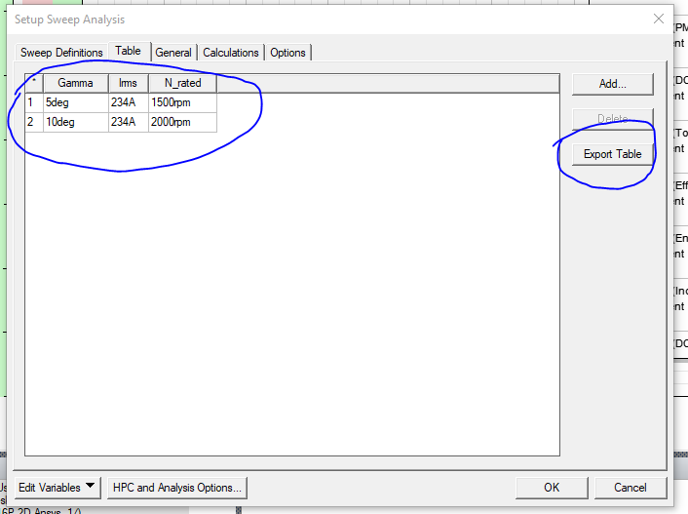

Step 4: Now when the above is done, right click on the ParametricSetup, then click on the Validatefor LargeScaleDSO, if the model or the results are not in the right format, then it will give error , if it is correct then it will give no error and may give you something like which is shown in the pic below.
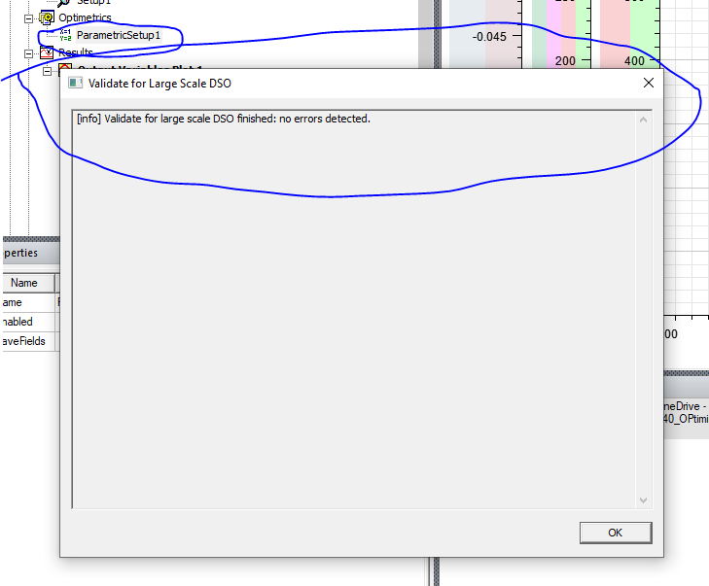

Step 5: then right click on the ParametricSetup > SubmitJob> the window will open as shown below and then tick the box Use large scale DSO as shown below.
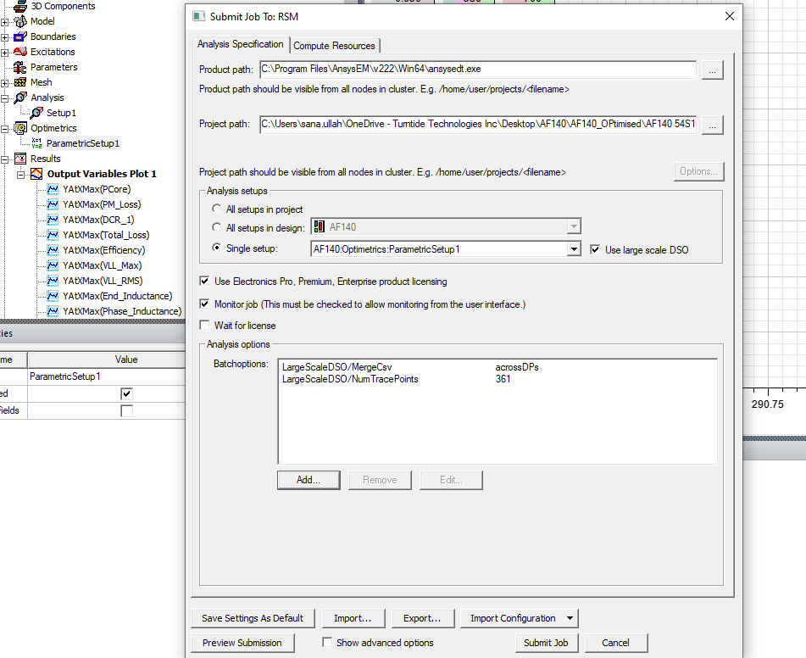
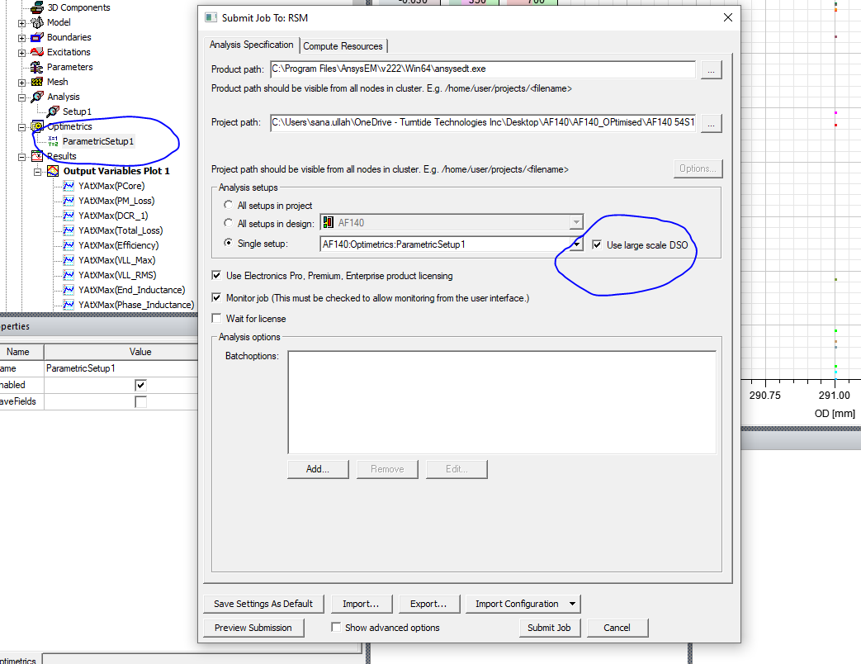
Then click on Add , then within Show registry by entries , click on LargeScaleDSO and include the following two files as shown in the pic below.
LargeScaleDSO/MergeCSV – (This is done to get the results in a single CSV file which make thigs easier)
LargeScaleDSO/NumTracePoints – value - 361
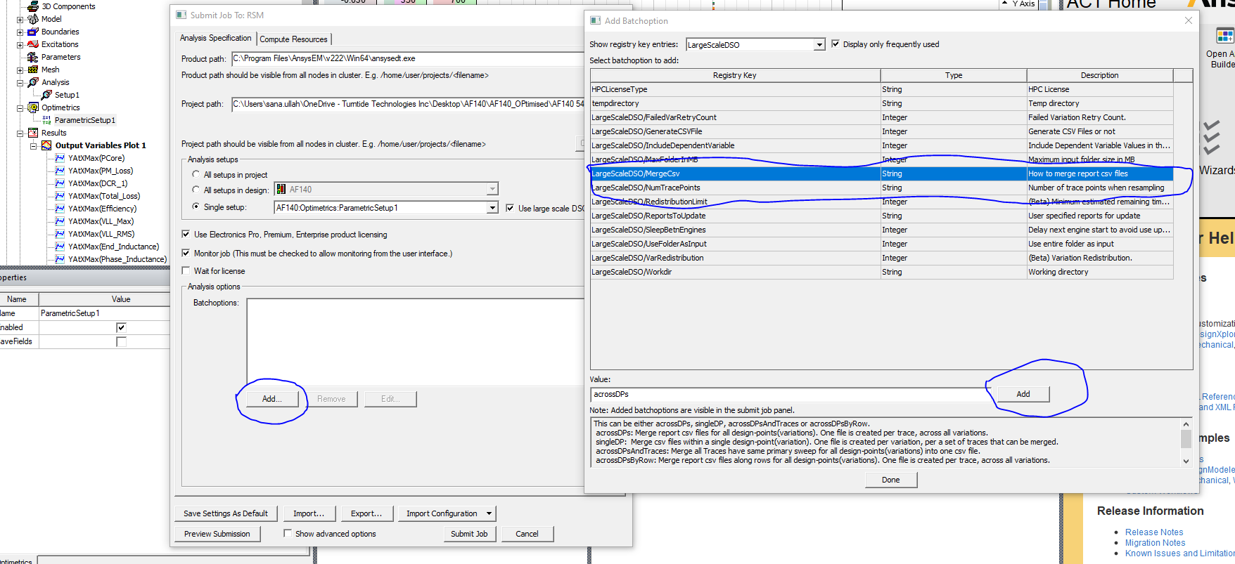
Then click again on Add , then within Show registry by entries , click on Maxwell 2D and include the following 5 files as shown in the pic below.
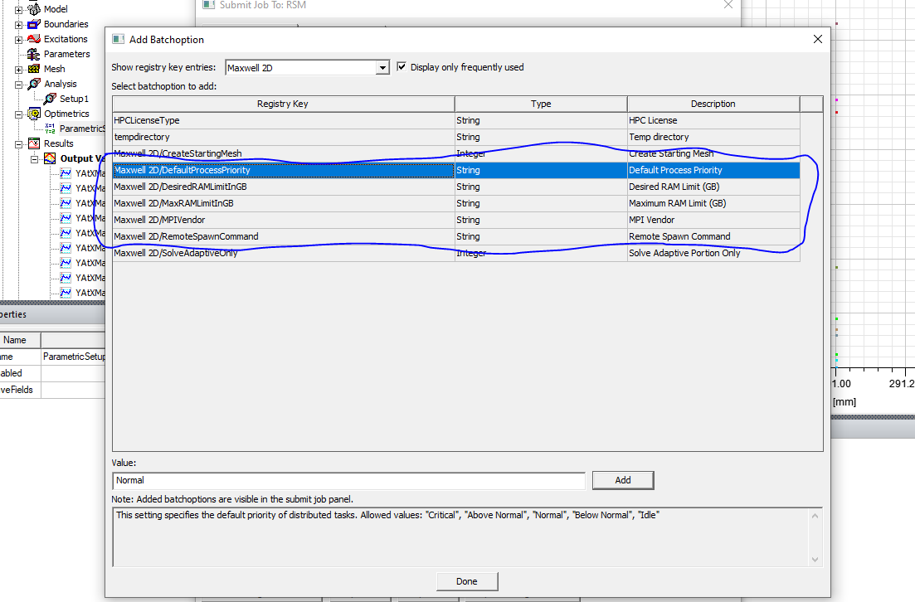

Then eventually the Submit Job to:RSM will look like as shown in the picture below.
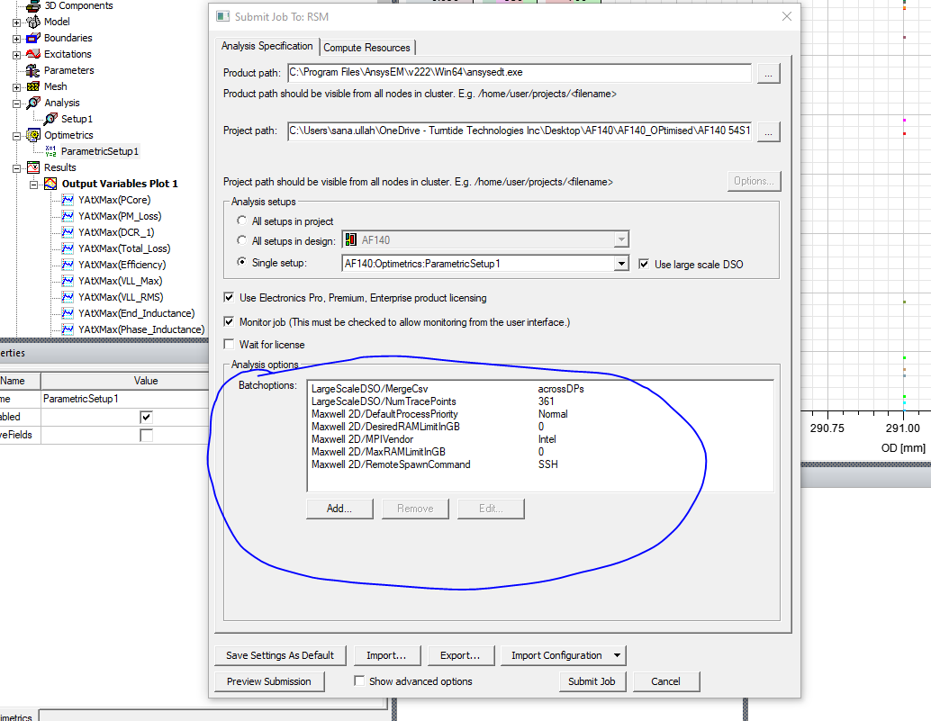
Step 6 – Now in the Submit Job To:RSM window click on the Compute Resources > Try to make the tasks = 16 or 32 depends on the PC strength and Cores = 32 or 40 (again depends on the computational power available).
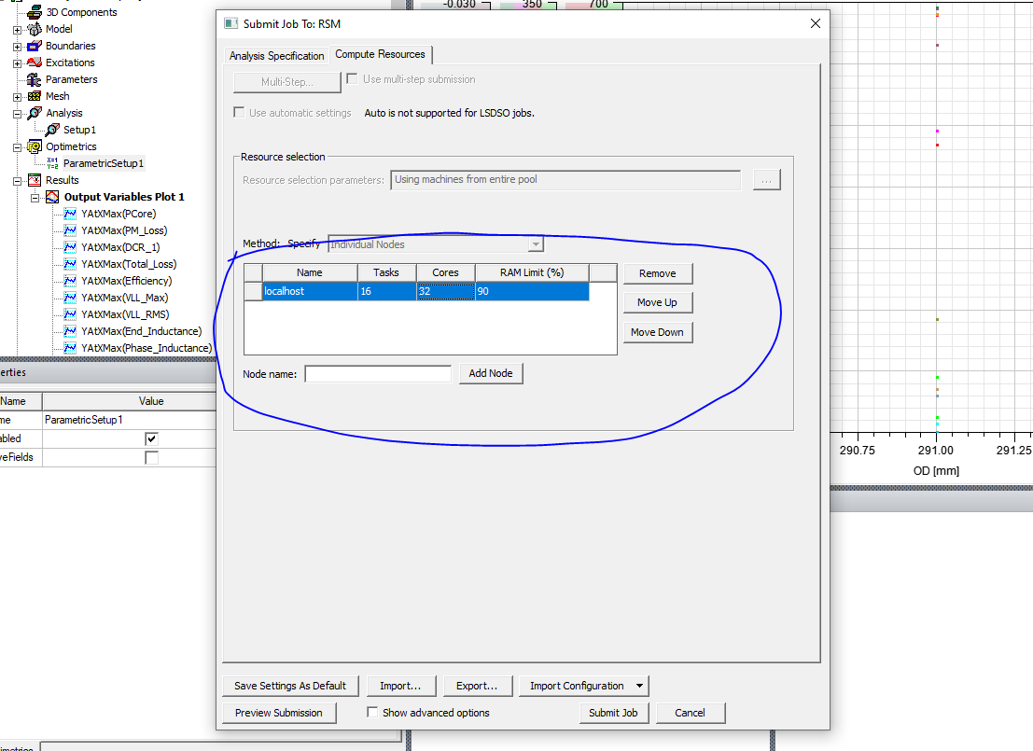

Step 7 – Then click on Submit Job, if the application is open, then it will ask it that it will close it, allow it by clicking yes and then it will start running the simulations.
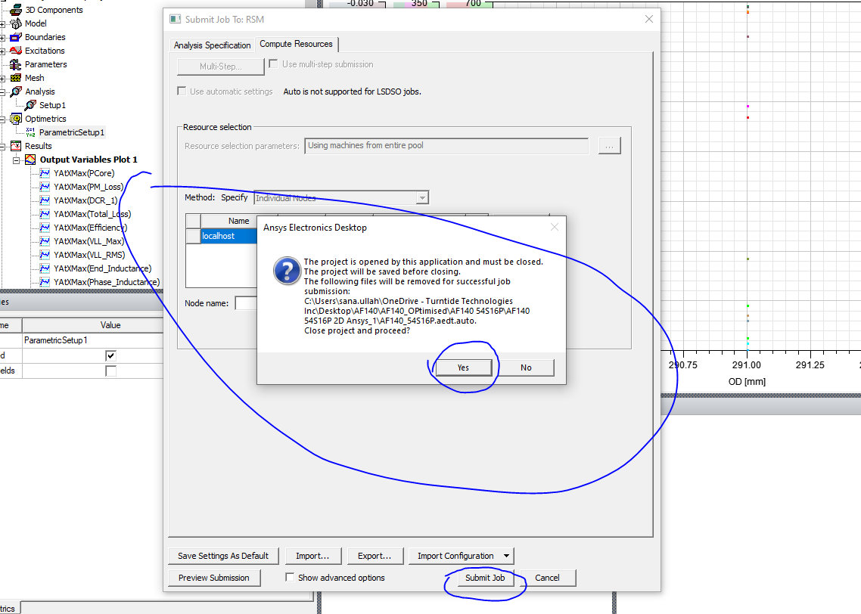
Now when the simulation completes , then now you can find all the values that you wanted to find before in the RSM_results section. So you go to file_name.results > RSM_results (this name is normally given before you start simulating the model ) and there you will find the CSV files (last row within each CSV file). This will include T_shaft, Vll_RMS and all the values that you defined in step one results section.

